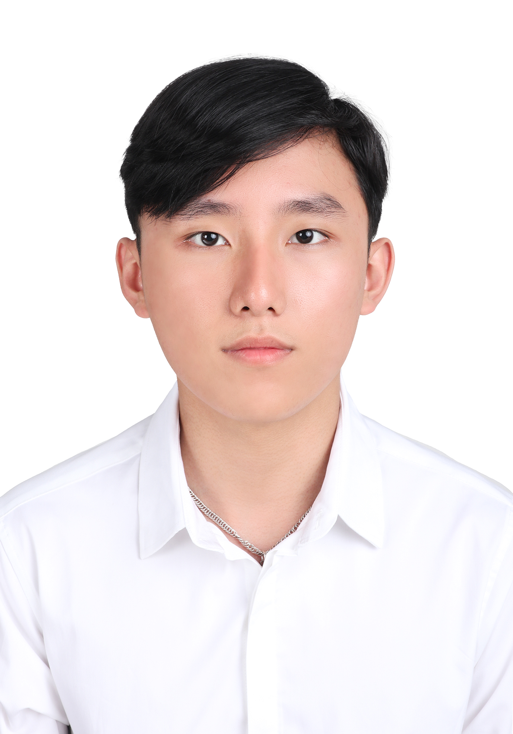

**Nguyen Ba Truong**

**Salesforce Developer**

|  |
| --- |
| **1) OVERVIEW** |

|  |  |
| --- | --- |
| Full name: | Nguyen Ba Truong |
| Date of Birth: | 18/08/2001 |
| Gender: | Male |
| Nationality: | Vietnamese |
| Mobile: | (+83) 93 521 8303 |
| Email: | [batruongnguyen2001@gmail.com](mailto:batruongnguyen2001@gmail.com) |

|  |
| --- |
| **2) TECHNICAL SKILLS** |

|  |  |
| --- | --- |
| Salesforce Development | * Apex * Aura Framework * Visualforce Pages and Components * Triggers and Batch Processes * Integration with REST and SOAP APIs |
| Salesforce Tools & Platforms | * Salesforce Lightning Platform * Salesforce IDEs (e.g., VS Code with Salesforce Extensions) * Data Loader and Data Import Wizard |
| Database & Data Management | * Salesforce Object Query Language (SOQL) * Data Modeling and Schema Design |
| Version Control & Collaboration | * Git and GitHub/GitLab * Agile and Scrum Methodologies * Collaborative Development with Teams |
| Front-End Development | * HTML * CSS * JavaScript * Lightning Design System (SLDS) |
| Other Tools and Technologies | * JSON * Apex Unit Testing |
| Debugging and Troubleshooting | * Debug Logs and Debugging Techniques * Error Handling and Exception Management |
| Migration and Deployment | * Sandbox Environments * Salesforce CLI |

|  |
| --- |
| **3) WORK EXPERIENCE** |

|  |  |
| --- | --- |
| **May 2022 – Present** | **Datahouse Asia**  Salesforce Developer |

* Researched and integrated new technologies, enhancing project functionality and competitiveness.
* Managed team tasks and efforts, promoting collaboration and timely project completion.
* Translated business requirements into effective technical solutions, collaborating with cross-functional teams.
* Developed robust applications using Salesforce tools and methodologies, focusing on code quality and performance.
* Optimized system efficiency by addressing bottlenecks and streamlining processes.

|  |
| --- |
| **4) LIST OF PROJECTS** |

|  |  |
| --- | --- |
| **Projects:** | **CAMA** |
| Description: | The Computer-Assisted Mass Appraisal (CAMA) system is being developed for the San Diego County Assessor-Recorder-County Clerk (ARCC) Office. Its primary purpose is to enhance property appraisals by accurately assessing market values and handling unique property appraisals. |
| Duration: | 1 year 6 months |
| Team size: | 30 members |
| Responsibility: | Salesforce Developer   * Fix bugs and implement change requests. * Develop from detail design document. * Documentation development process. |
| Technologies: | Apex, Trigger, Batch Processes, REST APIs, Aura Framework, Javascript, SLDS, JSON, Salesforce IDEs, Data Loader, Data Import Wizard, Apex Unit Testing, Data Modeling and Schema Design |

|  |  |
| --- | --- |
| **Projects:** | **Student Management System** |
| Description: | A Salesforce application for Da Nang Economic University Student Management System |
| Duration: | 3 months |
| Team size: | 1 member |
| Responsibility: | Owner   * Designed Salesforce data model for efficient student records, requests, and administrative data management. * Created custom solutions in Salesforce to streamline student request workflows and notifications. |
| Technologies: | Apex, Trigger, Javascript, Data Modeling and Schema Design |

|  |
| --- |
| **5) LANGUAGE SKILLS** |

|  |  |
| --- | --- |
| Vietnamese: | Native language |
| English: | Good at verbal English, able to read/write technical documents |

|  |
| --- |
| **6) EDUCATION/QUALIFICATIONS** |

|  |  |
| --- | --- |
| Aug 2019 – Jul 2023 | University of Economics (DUE)  GPA: 3.30 |
| Aug 2023 | Salesforce Certified Platform Developer I |

|  |
| --- |
| **7) OTHER SKILLS/SPECIAL ACHIEVEMENTS** |

* Good soft skills, team works
* Fast learning, self-motivated